Yeshwantrao Chavan College of Engineering, Nagpur
Department of Artificial Intelligence & Data Science

Innovative Method Submission: Project Based Learning
Handwritten Digit Recognition Using Machine Learning

Submitted by
Name | Roll No. | Division
Tanmay Baingane | 166 | B
Tanmay Kamthekar | 167 | B
Tavakkal Sheikh | 168 | B

Subject: Fundamentals Of Machine Learning Faculty: Ganesh Yenurkar Sir
Academic Year 2026-27

Abstract
In this project we made a machine learning system that reads handwritten digits (0 to 9) from small images. We used the Digits dataset, which has 1,797 images of size 8 x 8 pixels. We trained six models: Logistic Regression, KNN, SVM, Decision Tree, Random Forest and Naive Bayes. We compared them using accuracy, precision, recall, F1-score and 5-fold cross-validation.
Along with the normal comparison, we added two extra experiments. First, we used PCA to find out how many of the 64 pixel features are really needed. Second, we added random noise to the test images to check which models still work when the images are not clean. The SVM model was the best with 99.17% accuracy, and it made only 3 mistakes out of 360 test images. PCA showed that about 15 features are enough to get almost the same accuracy. The noise test showed that some models, like SVM and KNN, are very strong with noise, while Naive Bayes breaks down quickly.

1. Introduction
Reading handwriting is easy for humans, but not so easy for computers. Every person writes a digit in a slightly different way. Digit recognition is used in real life in many places, such as reading postal PIN codes on letters, reading cheque amounts in banks, and scanning forms.
Machine learning helps here. We show the computer many example images along with the correct digit, and it learns the pattern by itself. After that, it can guess the digit in a new image it has never seen.
Many student projects only check which model gives the highest accuracy. In this project we went a little further. We also checked how many features are really needed and how the models behave when the images are noisy, because real-life images are rarely perfect.

2. Problem Statement
Given a small grayscale image of a handwritten digit (8 x 8 pixels), predict which digit from 0 to 9 it is. The system should be tested properly using different metrics, should work with fewer features if possible, and should still work reasonably when the image has noise.

3. Objectives
- To train and compare six different ML models on the same data.
- To evaluate each model using accuracy, precision, recall, F1-score and cross-validation.
- To use PCA and find how many features are enough without losing much accuracy.
- To test how each model performs when noise is added to the images.
- To study the mistakes of the best model using a confusion matrix and wrong-prediction images.

4. Dataset
We used the Digits dataset that comes inside scikit-learn, so no download is needed. It has 1,797 images of handwritten digits. Each image is 8 x 8 pixels, which means 64 pixels in total. Each pixel is a number from 0 (white) to 16 (darkest). So every image is basically a list of 64 numbers, and these 64 numbers are our features.
Property | Value | Note
Total images | 1,797 | -
Image size | 8 x 8 | 64 pixels
Features | 64 | one per pixel
Classes | 10 | digits 0 to 9
Pixel values | 0 to 16 | same scale for all pixels
Training images | 1,437 | 80%
Testing images | 360 | 20%
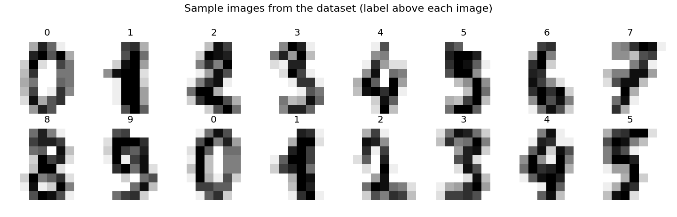
Figure 1: Sample images from the dataset
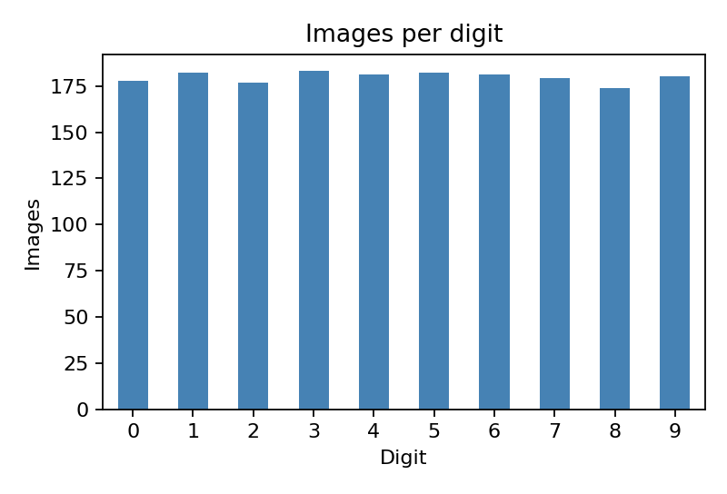
Figure 2: Number of images for each digit
The graph shows that each digit has almost the same number of images (around 180). This means the data is balanced, so accuracy is a fair metric to use here. We still report precision, recall and F1-score as well, to be more complete.

5. Methodology

5.1 Pre-processing and split
We split the data into 80% for training (1,437 images) and 20% for testing (360 images). We used stratified splitting, so every digit appears in the same proportion in both parts. We also used random_state=42 so that the results come out the same every time.
We did not scale the pixels. All 64 pixels are already on the same scale (0 to 16), so scaling is not needed. This also turned out to be important later for the noise test (see Section 7.5).

5.2 Models used
Model | Setting
Logistic Regression | max_iter=3000
K-Nearest Neighbours (KNN) | k=3
SVM (RBF kernel) | default settings
Decision Tree | default settings
Random Forest | 200 trees
Naive Bayes | Gaussian Naive Bayes

5.3 Evaluation metrics
Since there are 10 classes, precision, recall and F1 are calculated for each digit and then averaged (macro average).
- Accuracy: out of all images, how many were predicted correctly.
- Precision: when the model says a digit is, for example, 7, how often it is really 7.
- Recall: out of all real 7s, how many the model found.
- F1-score: a single number that balances precision and recall.
- Cross-validation accuracy: we split the training data in 5 parts and test 5 times. This shows that the result is not just luck.
- Confusion matrix: a table showing which digits get confused with which.

5.4 Innovative part 1: PCA
PCA (Principal Component Analysis) combines the 64 pixels into a smaller number of new features that keep most of the important information. We tried 5, 10, 15, 20, 30, 40 and 64 components with the SVM model, to see how few features we can use without losing accuracy. Fewer features means a faster and lighter model.

5.5 Innovative part 2: Noise test
Real images are often blurry or have random dots. To check this, we trained all the models on clean images, and then added random noise to the test images. We used 5 noise levels (0 to 4), where 0 means clean images and 4 means a lot of noise. This shows which models are reliable in difficult conditions.

6. Implementation (Python Code)
The whole project is written in one Python file (project.py) using pandas, NumPy, scikit-learn and Matplotlib. The code is shown below in parts. The output of each part is shown in Section 7.
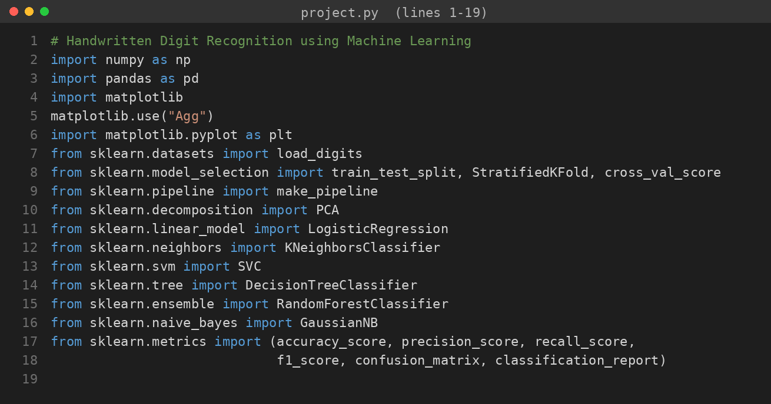
Figure 3: Importing libraries
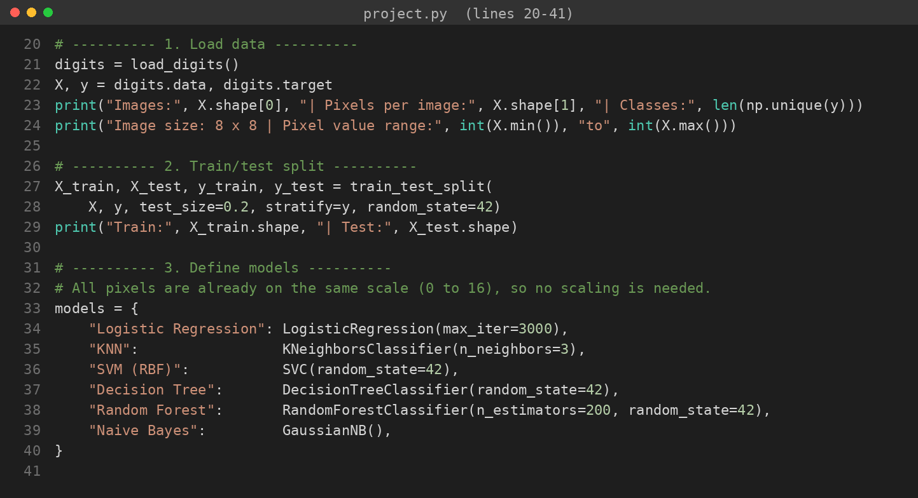
Figure 4: Loading the data, splitting it and defining the six models
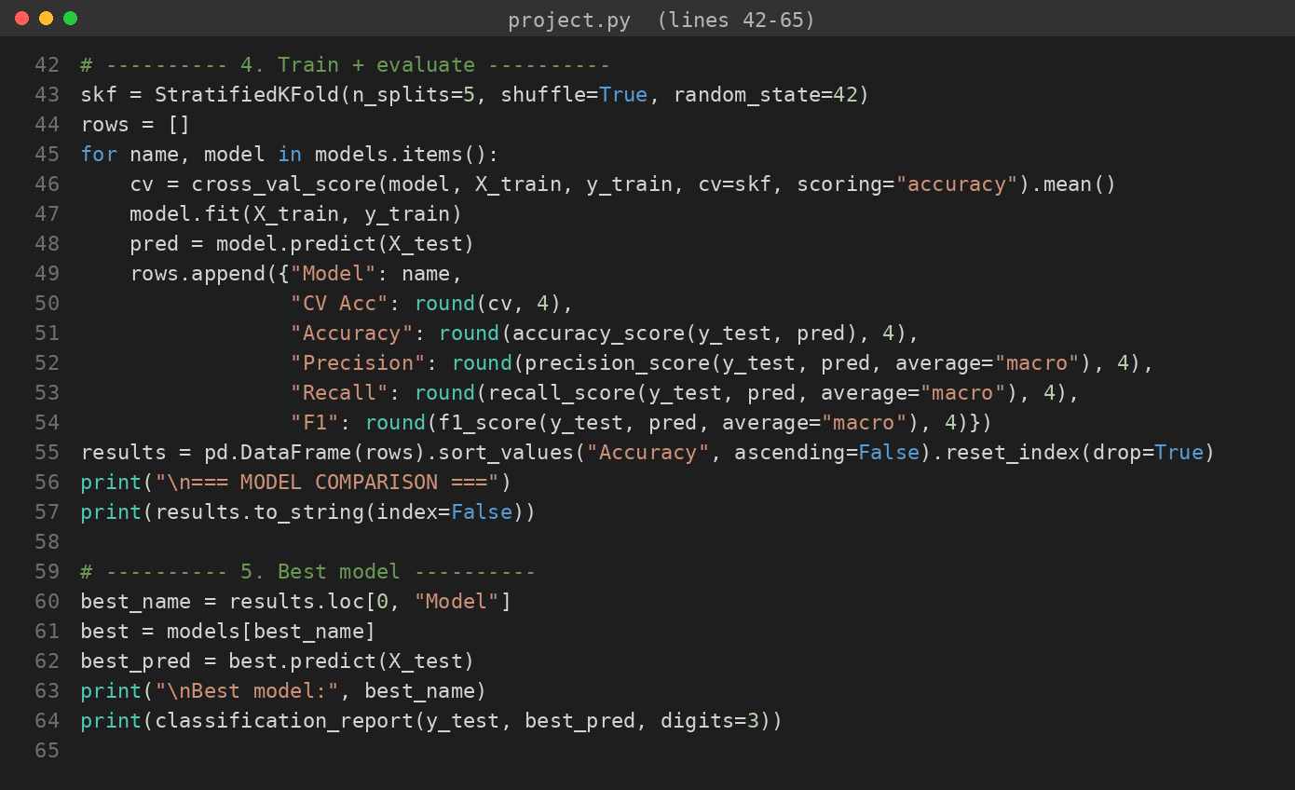
Figure 5: Training the models and calculating the metrics
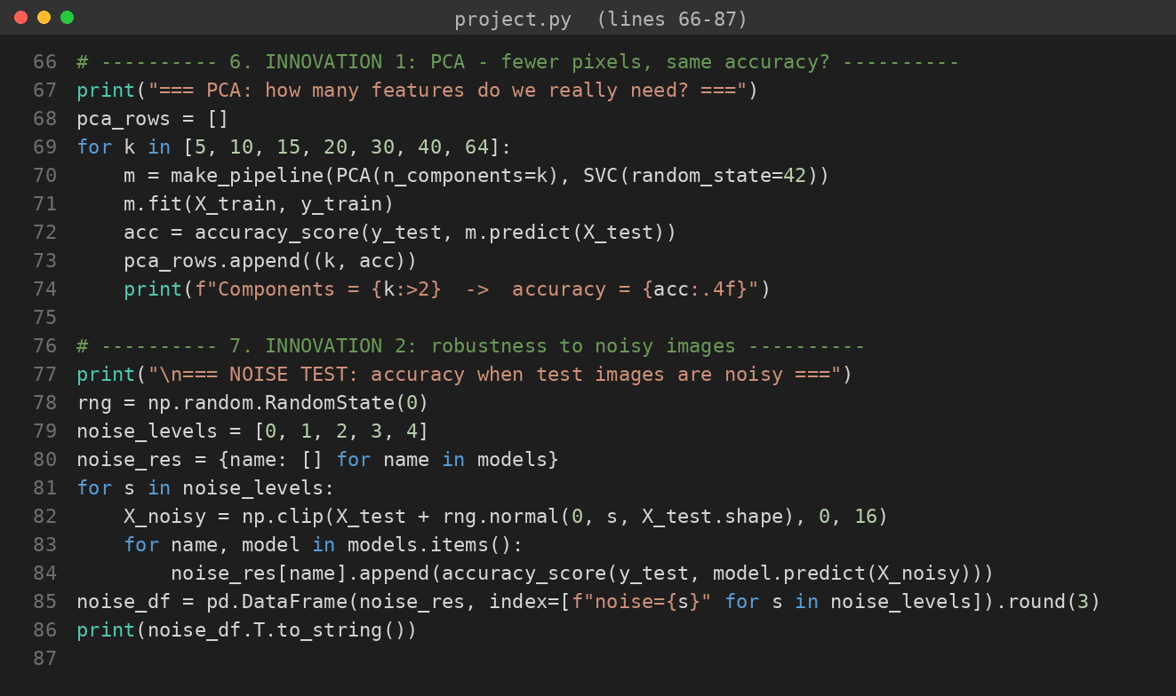
Figure 6: PCA experiment and noise test (innovation)
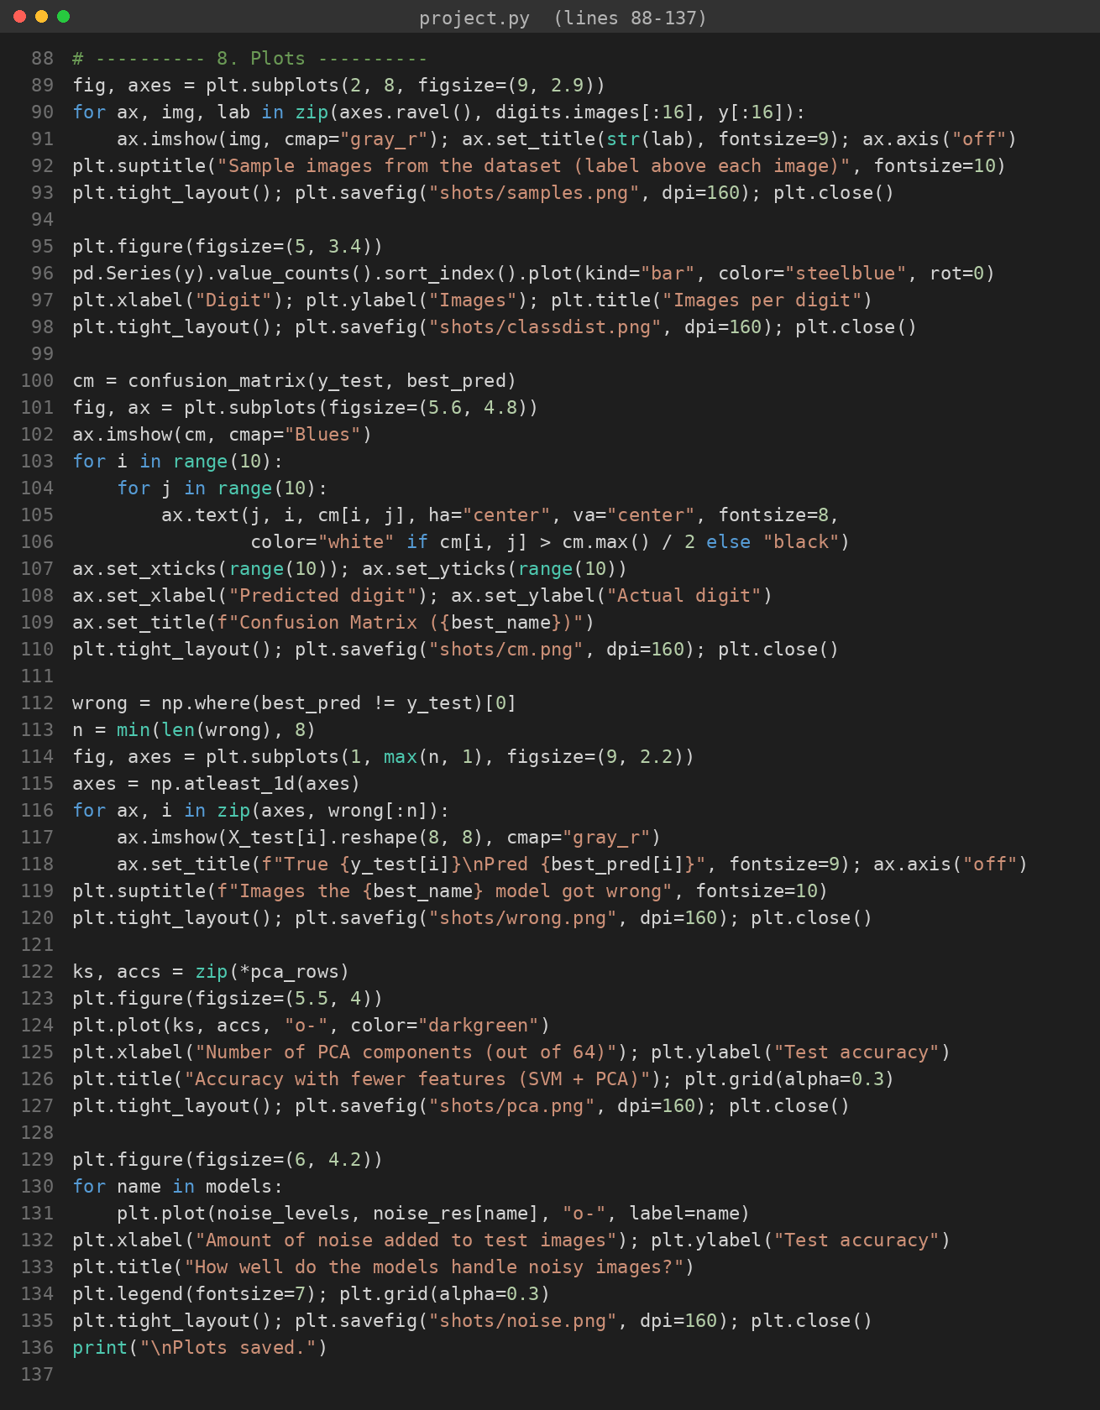
Figure 7: Code for the graphs and plots

7. Results and Discussion

7.1 Dataset details
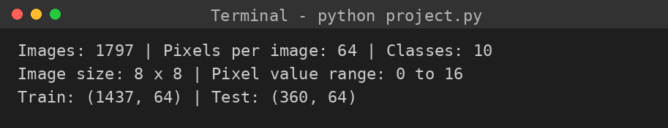
Figure 8: Dataset summary and train/test split

7.2 Model comparison
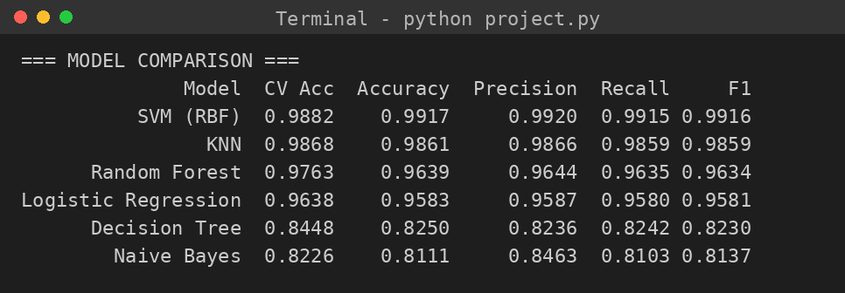
Figure 9: Performance of all six models on the test set
Model | CV Acc | Accuracy | Precision | Recall | F1
SVM (RBF) | 0.9882 | 0.9917 | 0.9920 | 0.9915 | 0.9916
KNN | 0.9868 | 0.9861 | 0.9866 | 0.9859 | 0.9859
Random Forest | 0.9763 | 0.9639 | 0.9644 | 0.9635 | 0.9634
Logistic Regression | 0.9638 | 0.9583 | 0.9587 | 0.9580 | 0.9581
Decision Tree | 0.8448 | 0.8250 | 0.8236 | 0.8242 | 0.8230
Naive Bayes | 0.8226 | 0.8111 | 0.8463 | 0.8103 | 0.8137

SVM gave the best result, with 99.17% test accuracy and 98.82% cross-validation accuracy. KNN was a close second. Both of these work well for images because they can handle curved and complex boundaries between digits. Decision Tree and Naive Bayes were the weakest, with accuracy around 81 to 83%. Naive Bayes assumes that all pixels are independent of each other, which is not true for images, because neighbouring pixels are strongly related.
The cross-validation scores are close to the test scores for the top models, which tells us that the results are stable and not just luck from one split.

7.3 Best model: detailed results
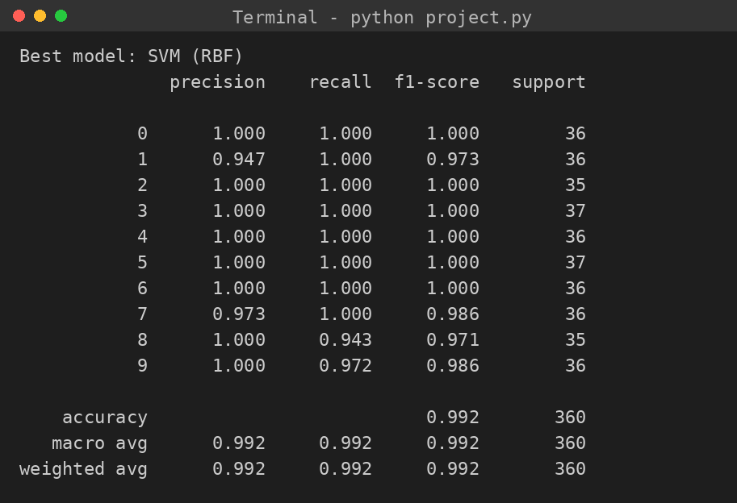
Figure 10: Classification report of the SVM model
SVM got perfect scores (1.00) for digits 0, 2, 3, 4, 5 and 6. The slightly lower scores were for digits 1, 7, 8 and 9, but even those are above 94%. Overall it made only 3 wrong predictions out of 360 images.
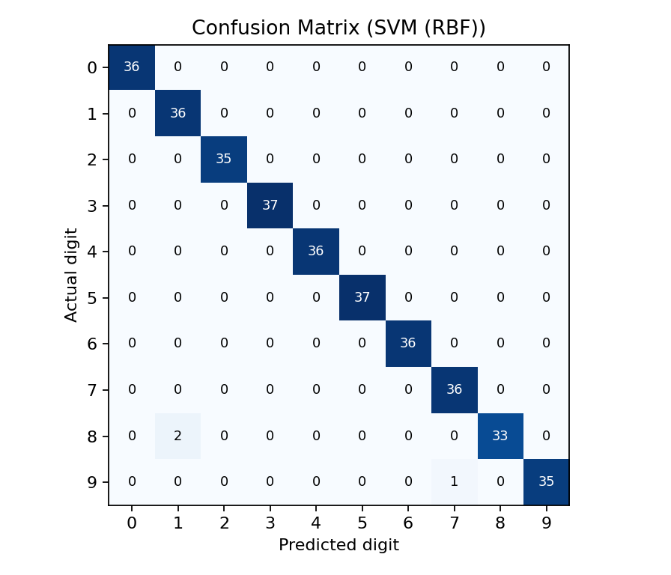
Figure 11: Confusion matrix of the SVM model
The numbers on the diagonal are the correct predictions. The few numbers outside the diagonal are the mistakes. Let us look at those wrong images.
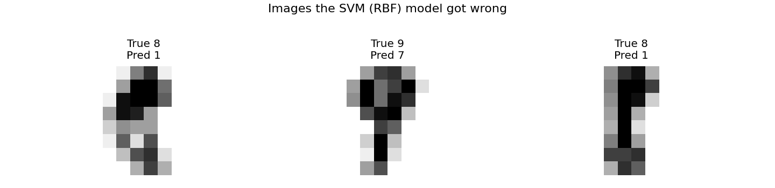
Figure 12: The images that SVM predicted wrongly
When we look at these images, they are very unclear or badly written even for a human, so it is understandable that the model got confused.

7.4 PCA experiment: how many features do we need?
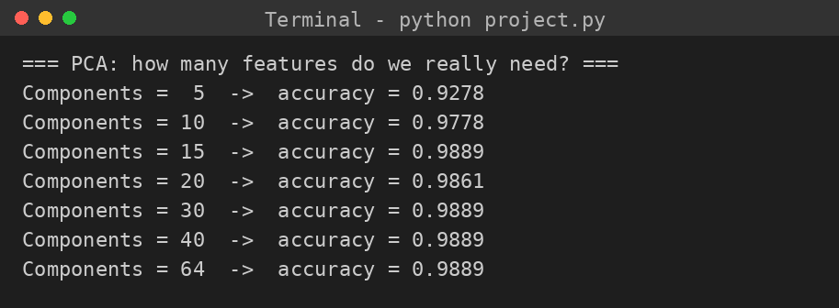
Figure 13: Accuracy for different numbers of PCA components
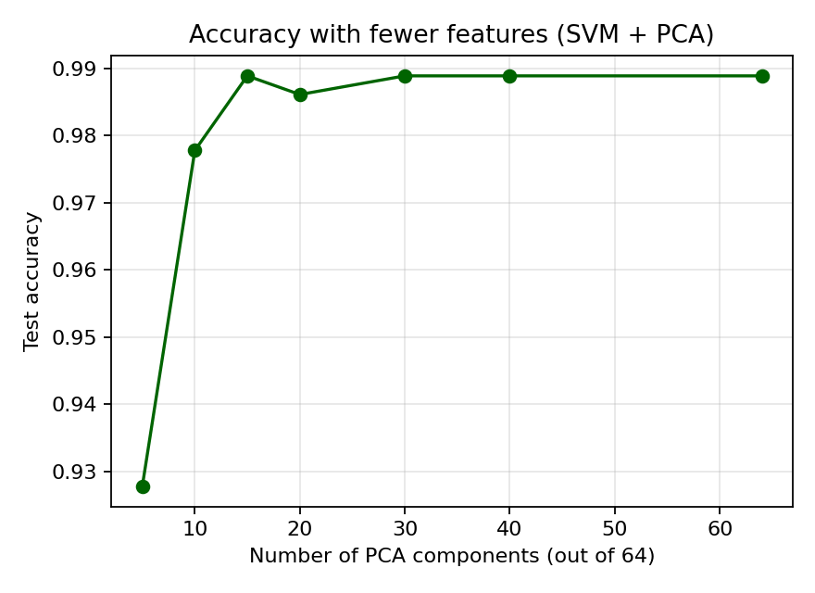
Figure 14: Accuracy versus number of components
PCA components (out of 64) | Test accuracy
5 | 92.78%
10 | 97.78%
15 | 98.89%
20 | 98.61%
30 | 98.89%
40 | 98.89%
64 (all features) | 98.89%

With only 15 components the accuracy is 98.89%, which is the same as using all 64 components. That means about 77% of the features can be removed without losing accuracy. Even with just 10 components, accuracy is 97.78%. The accuracy graph becomes flat after 15, which means the extra components do not add useful information. This is useful for making a faster model or for devices with less memory.
Note: the PCA models give 98.89%, while the SVM on raw pixels gave 99.17%. This difference is just one image out of 360, so it is very small.

7.5 Noise test: which model is more reliable?
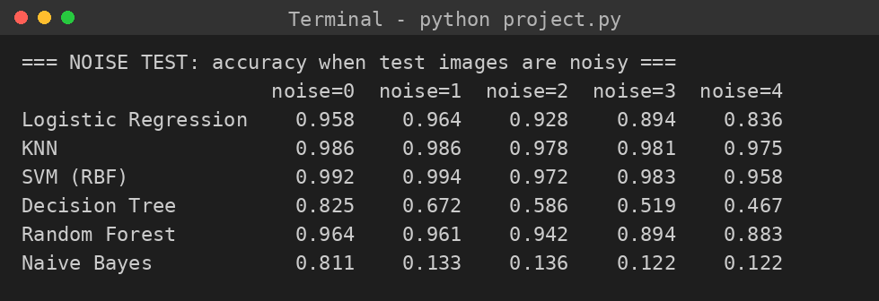
Figure 15: Accuracy of each model at different noise levels
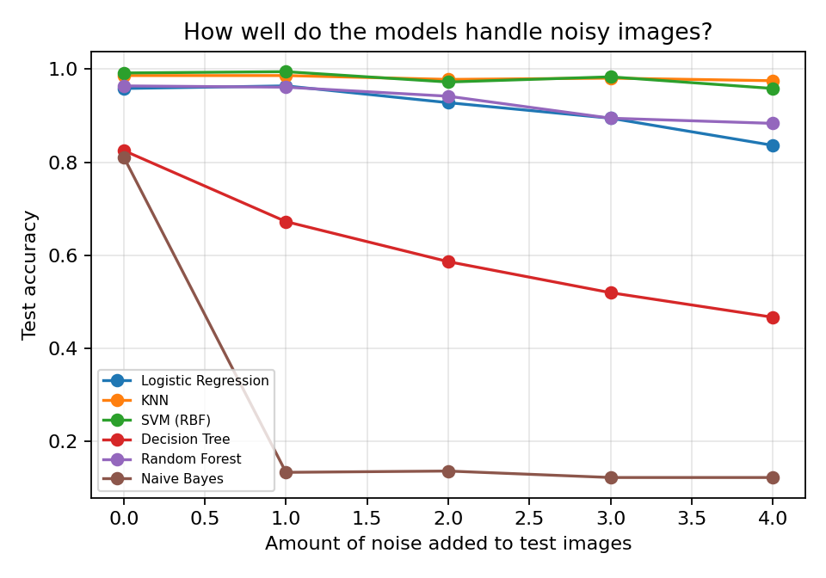
Figure 16: Effect of noise on the models
Model | Noise 0 | Noise 1 | Noise 2 | Noise 3 | Noise 4
SVM (RBF) | 0.992 | 0.994 | 0.972 | 0.983 | 0.958
KNN | 0.986 | 0.986 | 0.978 | 0.981 | 0.975
Random Forest | 0.964 | 0.961 | 0.942 | 0.894 | 0.883
Logistic Regression | 0.958 | 0.964 | 0.928 | 0.894 | 0.836
Decision Tree | 0.825 | 0.672 | 0.586 | 0.519 | 0.467
Naive Bayes | 0.811 | 0.133 | 0.136 | 0.122 | 0.122

SVM and KNN stayed above 95% even at the highest noise level, so they are the most reliable. Random Forest and Logistic Regression dropped slowly but were still usable. The Decision Tree dropped a lot, because one tree depends on exact pixel values. Naive Bayes fell to about 12 to 13% even at the lowest noise level, which is close to random guessing for 10 classes (10%). A likely reason is that the border pixels of the training images are almost always 0, so Naive Bayes treats any non-zero value there as extremely unlikely, and noise makes all of them non-zero.
An important thing we learned: at first we used StandardScaler for SVM and KNN, and their accuracy on noisy images fell to around 13%. The reason is that scaling makes the almost-constant border pixels very sensitive, so noise gets magnified. When we removed the scaling, SVM became very strong against noise. Since all pixels are already between 0 and 16, scaling was not needed anyway. So the lesson is that a common step like scaling is not always helpful, and we should test it.

8. Innovation Summary
- PCA analysis to show that about 15 features out of 64 are enough.
- Noise robustness test to compare the models under difficult, real-life conditions.
- Detailed error analysis using the confusion matrix and pictures of wrong predictions.
- Testing the effect of feature scaling and discovering that it hurts noise robustness for this data.

9. Conclusion
In this project we built and compared six machine learning models for recognising handwritten digits. The SVM model was the best with 99.17% accuracy and made only 3 mistakes in 360 images, and KNN was close behind. PCA showed that around 15 features are enough to get nearly the same accuracy as all 64. The noise test showed that SVM and KNN are the most reliable on noisy images, while Naive Bayes fails quickly. So choosing a model should depend not only on the accuracy on clean data but also on how it behaves in real conditions.

10. Limitations and Future Scope
- The images are very small (8 x 8) and clean. Real handwriting photos are bigger and messier.
- The dataset is small, with only 1,797 images.
- We used mostly default settings. Hyperparameter tuning with GridSearchCV might improve the results.
- The noise we added is random noise only. Real-life problems like rotation, thickness change or blur were not tested.
- Future work: try the bigger MNIST dataset (28 x 28 images) and a CNN (deep learning) model, and build a small app where the user can draw a digit and get the prediction.

11. References
- Alpaydin, E., & Kaynak, C. Optical Recognition of Handwritten Digits Data Set. UCI Machine Learning Repository.
- Pedregosa, F. et al. (2011). Scikit-learn: Machine Learning in Python. Journal of Machine Learning Research, 12, 2825-2830.
- scikit-learn documentation: load_digits, PCA, SVC, cross_val_score. https://scikit-learn.org
- Hunter, J. D. (2007). Matplotlib: A 2D graphics environment. Computing in Science & Engineering, 9(3), 90-95.

